Extract from Horizon Europe Strategic Plan 2025-2027 Analysis
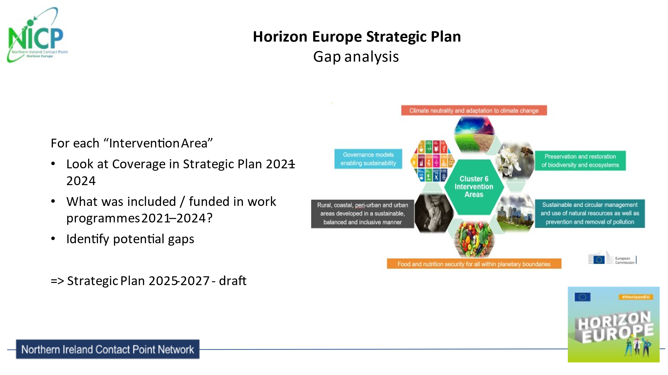
Extracted from Table 21. Gap analysis for Cluster 6 – food, bioeconomy, natural resources, agriculture and environment – Summary of potential gaps.
Environmental Observation
- Improvement of EU governance on EO, international coordination, development of standards and good practices, and harmonisation of data management and data technologies
- Monitoring and assessment of biodiversity
- Integration of biodiversity data across domains and methods
- Zero pollution, covering pollution in oceans and water (including groundwater, underwater noise), air and soil pollution, microplastics and nanoplastics, nutrients and pollutants of emerging concern
- Improvement of the monitoring of air quality
- Agricultural monitoring
Biodiversity and natural resources
Potential gaps regarding the need for improved understanding and mitigation of drivers of biodiversity loss, including knowledge about biodiversity status and trends, are:
- the impact of climate change
- issues of emerging concern
- cumulative impacts
- monitoring of key geographic and taxonomic gaps, ecosystem functions, species interactions, key drivers and pressures and socioeconomic aspects
- addressing of the decline of insects population and of key species
- valorisation of past observations and existing datasets
- addressing of the impacts of war on biodiversity
Potential gaps regarding the need for improved methods for and knowledge of biodiversity protection and restoration include knowledge and methods for:
- the protection and restoration of all targeted ecosystems, habitats and species, as laid down in the proposal for the Nature Restoration Law
- the protection of species
- the identification of the most suitable areas for restoration
- the identification and testing of suitable indicators
- support for the preparation and implementation of national restoration plans
- support for revision of lists of protected habitats and species
- the identification of funding, governance and managing opportunities for both biodiversity and climate
- the improvement of modelling and protection of data on nature
Potential gaps regarding transformative change in which biodiversity is mainstreamed in society and the economy include:
- innovative tools and methods to ensure citizen engagement in biodiversity conservation
- quantification of economic benefits of nature protection and restoration, and costs of non-action
- development of sustainable economic models ensuring biodiversity protection, including methods to quantify and incentivise sustainability co-benefits of carbon removal activities on biodiversity and ecosystems
- a nature-positive economy
- Potential gaps regarding biodiversity and health include:
- remaining gaps on interlinkages between health and biodiversity
- links between nature and mental health
There is a potential gap regarding the connection between science and policy, at European and global levels, including support as needed according to the post-2020 global biodiversity framework (IPBES and the Convention on Biological Diversity).
Agriculture, forestry and rural areas
- Climate change. There is need to increase knowledge and tools to mitigate and adapt to climate change and its impacts, especially on the sustainability of permanent grassland and peatland; foster the resilience of crops; and address trade-offs of farming and related biodiversity adaption versus mitigation.
- Agroecology. There is need to increase knowledge and develop tools to foster agroecology; improve knowledge of the benefits and trade-offs of fostering systemic and circular agroecological approaches and biodiversity, including socioeconomic aspects and input cost reduction (depending on coverage under the agroecology living labs partnership); and bolster livestock organic production though breeding for resilience.
- Breeding and genetic resources. There is need to improve breeding and genetic resources for conservation (for crops and forest trees) and to reduce (agrochemical) inputs in agriculture.
- Pollution and biodiversity. There is a need to address challenges for soil, water, nutrient and biodiversity through methods such as integrated nutrient management plans, soil decontamination and carbon removal, research on the sublethal effects of pesticides on pollinators, water pollutants and their impact on environmental health and air pollution.
- Plant health. There is need to bolster plant health, manage pests and diseases, and support farmers meeting potential regulation requirements on the sustainable use of pesticides.
- Animal health and welfare. There is need for knowledge and tools to foster animal (positive) health and welfare (and synergies); the development of disease countermeasures (e.g. vaccines), including against parasitism; emerging risks; one health alternatives to antimicrobials and data systems (depending on coverage of partnership on animal health and welfare).
- Sustainable livestock systems. Knowledge and tools are needed to foster sustainable livestock systems in areas such as emission mitigation, circular approaches for livestock management, and the diversification of livestock systems for adaptation to climate change.
- Protein crops. There is a need to leverage the potential of protein crops through provision of advisory services, implementation of circular methods to valorise by-products, and assessment of the EU and global dynamics of pulse/protein crops for livestock feed and human diets.
- Rural areas. There is a need to stimulate rural social dynamics in areas such as improvement of community services, contribution to the energy transition, newcomers’ contributions, rural–urban synergies and innovation ecosystems.
- Urban agriculture. There is need to identify gaps and opportunities regarding innovative urban agriculture, and develop solutions to foster the sustainability transition.
- Sustainable bio-based solutions in rural areas. There is need for the development of sustainable bio-based products, including the production of renewable energy; introduction of nature-positive business models; and improvement of the position of farmers in bioeconomy value chains.
- Forestry. There is a need to foster multifunctional forests for future generations through sustainable management approaches, technologies, innovative wood and non-wood products, prevention and management of forest disturbances, urban forestry, management of genetic resources, deployment of inclusive and fair value chains, and improved governance.
- Digital and data technologies. There is need for enabling digital and data technologies (objectives of the long-term vision of rural areas) through the public administration’s implementation of legal frameworks on cyber and data technologies, and digital services; and increasing sustainability performance.
- AKIS. There is need for the development of AKIS of the future through understanding of the connection among multi-actor tools, research on skills, training and education for farmers, further AKIS thematic networks, generational renewal of farmers’ further support for AKIS development, and extension of the lifetime of demo farms.
- Value chains. Knowledge and innovation are needed to further support innovative policies, business models and value chains enabling sustainable food systems and agriculture, including tools for business education for farmers.
- International cooperation. There is need to foster international R & I cooperation, which is important for the geopolitical dimension in cross-cutting areas such as food production, water management, organic production, soil health, biodiversity, urban farming, forestry, rural areas and development of digital skills.
Seas, oceans and inland waters
There are potential gaps on the need to increase multidisciplinary R & I for healthy and productive ocean and seas, in particular:
- observing, valuing, restoring and protecting coastal and marine biodiversity and ecosystems services monitoring and capacity methods for indicator-based assessments of the state of the marine environment and marine protected areas
- freshwater and inland waters, particularly restoration methods for European lakes and freshwater ecosystems and reservoirs in a closely linkage with climate change and invasive species, and improving regulating ecosystem services
- sustainable fisheries and aquaculture, particularly producing R & I for organic aquaculture and for offshore aquaculture; reducing the impact of fisheries on the marine environment and on the seabed; and creating disruptive technological advances to modernise fisheries data collection, fisheries monitoring and control, and for efficiently fighting food fraud and illegal, unreported and unregulated fishing R & I; supporting the development of research on socioeconomic impacts of the adoption of new technologies and innovation in fisheries and aquaculture; and producing R & I on new environmentally friendly technologies in the fisheries and aquaculture sectors
- clean aquatic environment and zero pollution, particularly monitoring, assessing and mitigating the cumulative effects of different sources of pollution in ocean and waters, and producing accurate mapping and improving global governance of plastic pollution in a one health approach
- improved understanding of the ocean–climate–biodiversity nexus and of the polar regions in climate change mitigation and adaptation
- blue bioeconomy and biotechnology, particularly support for bioprospecting of marine natural products and omics advances for remediation of marine ecosystems resilient, inclusive, healthy and green coastal communities, supporting nature connectedness applied to aquatic environments
- innovative governance, particularly support for the international cooperation commitments
- technologies for the digital ocean, particularly integrated modelling (physics, biogeochemical, ecosystems) of the land–sea interface (coastal zones, rivers and estuaries), technologies for socioecological data and models, and technologies for user and impact-driven digital twin applications
Food systems
Along the food 2030 pathways, further R & I investments are required to foster the implementation of systemic approaches to deliver co-benefits and foster the deployment of solutions.
Potential gaps regarding environmental sustainability, circularity and resource efficiency of food systems, are related to:
- transitioning towards low-energy and low-carbon-footprint food systems, with a focus after primary production, considering the land–water–energy–food nexus
- reducing fossil fuel dependence across supply chains
- developing low-carbon-footprint food system solutions (e.g. precision fermentation) that are performant from a system perspective
Potential gaps regarding building food systems’ resilience are by better anticipating, preventing and reacting to crises, in particular climate change, at all levels, from local to global.
Potential gaps regarding contributing to biodiversity restoration are:
- tackling biodiversity from the angle of regenerative food systems (e.g. product-marketing strategies
- enhancing community engagement (at different scales) and the consumption of nutritious, environmentally sustainable foods from biodiversity-rich areas
- demonstrating food production business cases that are regenerative
A potential gap regarding food waste is improving the implementation of strategies to monitor, manage and valorise food waste.
A potential gap regarding pollution from food processing industries is addressing pollution from the food-and beverage-processing industries, and other downstream actors.
A potential gap regarding the traceability of food products is the development of effective digital systems and tools (e.g. fresh and processed fisheries and aquaculture products).
Bio-based innovation systems in the EU bioeconomy
Potential gaps regarding bio-based innovations (innovating sustainable bio-based systems and the bioeconomy, and increasing the environmental performance and sustainability of processes and products) are related to:
- the circularity of bio-based systems (focus on biowaste/recycling, waste management and valorisation), evaluation of the life cycle of bio-based products and bio-based technologies to improve recirculation in bio-based processes, and pollutant prevention, mitigation and control
- the safe-and-sustainable-by-design approach to bio-based value chains, and a better understanding of the carbon removal potential of bio-based economies
- biodiversity protection, restoration and enhancement, and zero pollution in the bio-based sector, including through NBS (Nature Based Solutions)
- the role of (sustainable, circular and climate-/biodiversity-friendly) primary resources in bio-based value chains enabled by biotechnology and other advanced approaches
- the environmental, social, economic and cultural dimensions of the sustainability of bio-based systems
- the lack of standards and criteria for the supply of sustainable biomass, including cultivation of industrial crops on marginal lands and biomass with low risk of indirect land use change
- the short lifetimes of bio-based products (upcycling and the role of consumers’ choices)
- the digitalisation of bio-based technologies
- biotechnology approaches (with a clearer focus on environmental accidents / pollution detection and remediation), healthy bio-based foods, alternative proteins and the microbiome
- demonstration of regenerative, blue, bio-based business cases tailored to the EU’s regional seas
Potential gaps regarding the bioeconomy (being innovative with governance models and supporting policies, and innovating sustainable bio-based systems and the bioeconomy) are related to:
- fostering of the bioeconomy in Member States / regions that are lagging behind
- development of innovative production and business models offering economic opportunities for primary producers and rural areas, and contribution to a fair distribution of benefits in fair value chains
- R & I, development and bioeconomy education in countries covered by the central-eastern European initiative for knowledge-based agriculture, aquaculture and forestry in the bioeconomy
- bioeconomy model regions
- bioeconomy solutions with the highest potential for climate mitigation, biodiversity restoration, water management, etc.
- regional innovation valleys for the bioeconomy and food systems
- sustainable and circular management of land and biomass demands that promotes more sustainable consumption patterns for environmental integrity, and youth participation and leadership
- societal acceptance of new bio-based solutions
- trust building in the bioeconomy/bio-based sectors underpinned by the social sciences and humanities
Circular systems
Potential gaps regarding the sectoral circular economy are:
- coherence between material and energy efficiency
- documentation of environmental impacts
- sharable datasets to inform future prioritisation
- Potential gaps regarding the territorial circular economy are:
- involvement of local and regional authorities in R & I projects
- further supporting and promoting innovative business cases, social norms, governance, and financing models in cities and regions
- mobilising further financial expertise for supporting cities and regions in translating project ideas into credible, robust and mature investment concepts
- facilitating replication and further deployment of local and regional circular systemic solutions
Potential gaps regarding water are:
- large-scale implementation of circular systems for water / water sludge reuse, and recovery of key nutrients
- resilience of water resource systems in the context of climate change and emerging energy and food crises
- alternative water supply solutions in the context of increasing water stress
- harnessing digital technologies / AI / machine learning in the water sector
- drought impacts on freshwater biodiversity and ecosystems under climate change scenarios
- knowledge and innovation on micropollutants in water systems, strategies and technologies to reduce biocides in water systems, and detection tools for the identification and characterisation of microplastics and nanoplastics in the environment

Horizon Europe strategic plan 2025-2027 analysis - Publications Office of the EU (europa.eu)

